Setup and Use of

Batch_Wrap and dx-batch uScripts

For Texas Batch Reporting

**Prerequisites**

1. The latest version of lib_DX10 installed and compiled. In this library.
2. The latest version of inc_DX10 installed on your system

This process describes the setup of the Batch_Wrap and dx-batch uScripts. The Batch_Wrap script manages the entire process and calls the TXBATCH5 CMHC process to create the Batch File containing the transactions for Registration, Registration Update, Follow-up, New Gen Meds and Community Based Assignments. It then calls the dx-batch uScript to create the DX Batch transactions using the new ICD-10 compliant format. This process appends the DX Batch transactions to the batch file created by the TXBATCH5 CMHC process, adds the correct footer transaction and optionally FTP’s the file to CARE and then archives the file.

Note: the dx-batch uScript uses a number of functions in the lib_DX10 library. One of the critical items in this library is the definition of the ICD-10 Effective date. There is a %define statement at the beginning of this library where this date is currently set to 10/01/2015. For testing purposes, this date may need to be adjusted



**Parmfile Setup**

1. You may use the TXB2015 Parmfile from GitHub as your template. The parms in sections 1-9 of this parmfile will need to be addressed for your Center.
2. Section 9 of the parmfile will need to be copied from your existing parmfile that is currently being used for your CARE batch.
   1. The section of your existing parmfile for the TXBatch program specifically dealing with the Diagnosis batch will need to be removed or commented out.
   2. There are a number of parms in your existing parmfile that will need to be removed or commented out (*) because these have been moved elsewhere in the TXB2015 parm
      1. REPORTONLY (If used)
      2. LIVEONLY (if used)
      3. COMPCODE
      4. BATCHNO
      5. USERID
      6. SEQOUT
3. Section 1 of the Parmfile is the step that sets all of this up. This is where the Batch_Wrap uScript is defined and launched and given the Parm to be that defines the behavior of the process.

Running from a Menu

1. Identify the desired menu
2. Enter 466 for Program
3. Set your desired Security Level
4. Enter your ParmFile name (TXB215)
5. 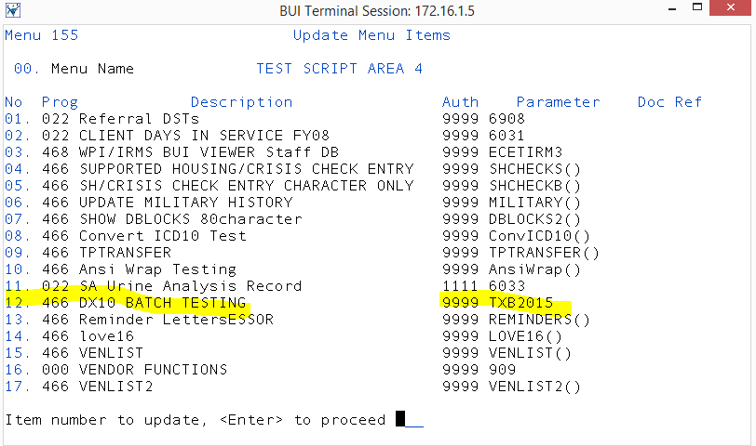

Executing the uScript

1. The first action the script will take is prompting for the CARE user ID and password that will be needed to submit the batch. Once this is entered, a quick $ftp command will verify the user’s CARE FTP credentials. If valid, the process will continue. If invalid, the process will notify the user and then stop processing. Note: If the parm “submitfile” section 5 of your Parmfile is set to “N”, the entry of the user ID and password is still required, but it will NOT be verified with CARE.

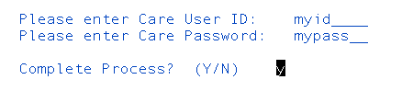

1. Any Holidays that are defined in in section 2 of the Parmfile array (holidays-1, holidays-2, etc.) will be checked against the system date. If there is a match, the user will be notified and the process will stop. Otherwise the process will continue.
2. Any Prescripts that are defined in section 6 of the Parmfile array (Prescript-1, Prescripts-2, etc.) will be executed in the background.
3. Once any Prescripts are complete, the familiar Texas Batch process screen will appear. This should be completed as usual.

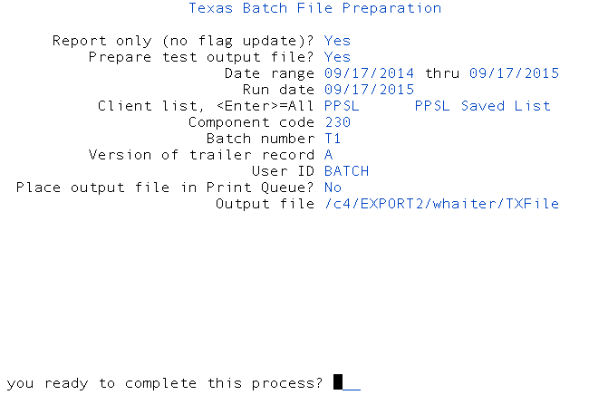

1. The next step creates the ICD-10 batch and appends the transaction to the batch file.

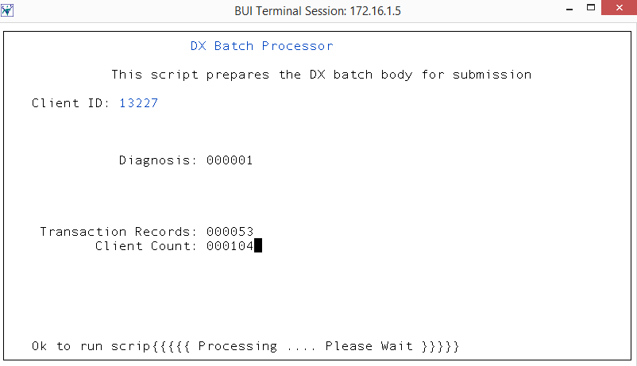

1. If the parm “submitfile” section 5 of your Parmfile is set to “Y”, the batch file will be submitted to the CARE FTP site using the credentials entered in step 1 of the process.

HF11121934